

**Gabelli School of Business**

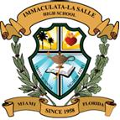

**Immaculata-LaSalle High School**

**Miramar United Elite FC**

www.tsmf.org

**The San Miguel Foundation**

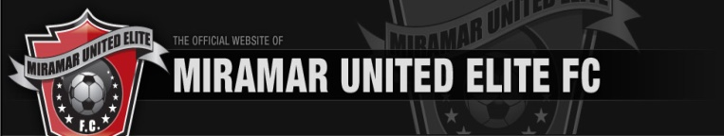

“…it is far better to light one candle than to curse the darkness…”

*-The Christophers prayer*

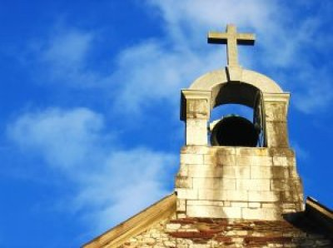

2019

History

Founded in 1999, The San Miguel Foundation seeks to make a difference in the world through the time commitment of its Officers and by providing financial support to charities.

Since its inception, the Foundation and its Officers have volunteered thousands of hours and contributed in excess of $580,000.00 to charities; principally in the South Florida area.

Activities

During the past several years, the Foundation provided support to approximately ten distinct organizations; including:

* Fordham University
* Immaculata-La Salle High School
* Miramar United Elite FC
* Blessed Ville Special School, and
* The Archdiocese of Miami
* St. Agnes Catholic Church

Contact Us

Grant requests should be submitted to the following for consideration:

**The San Miguel Foundation, Inc.**

**123 E. Enid Drive**

**Key Biscayne, FL 33149**

**or**

**president@tsmf.org**